Papers written by Australian Maths Software

SEMESTER TWO

MATHEMATICS SPECIALIST
REVISION 1
UNIT 3-4

2016

SOLUTIONS

Section One
1. (5 marks)
(i) 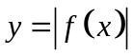
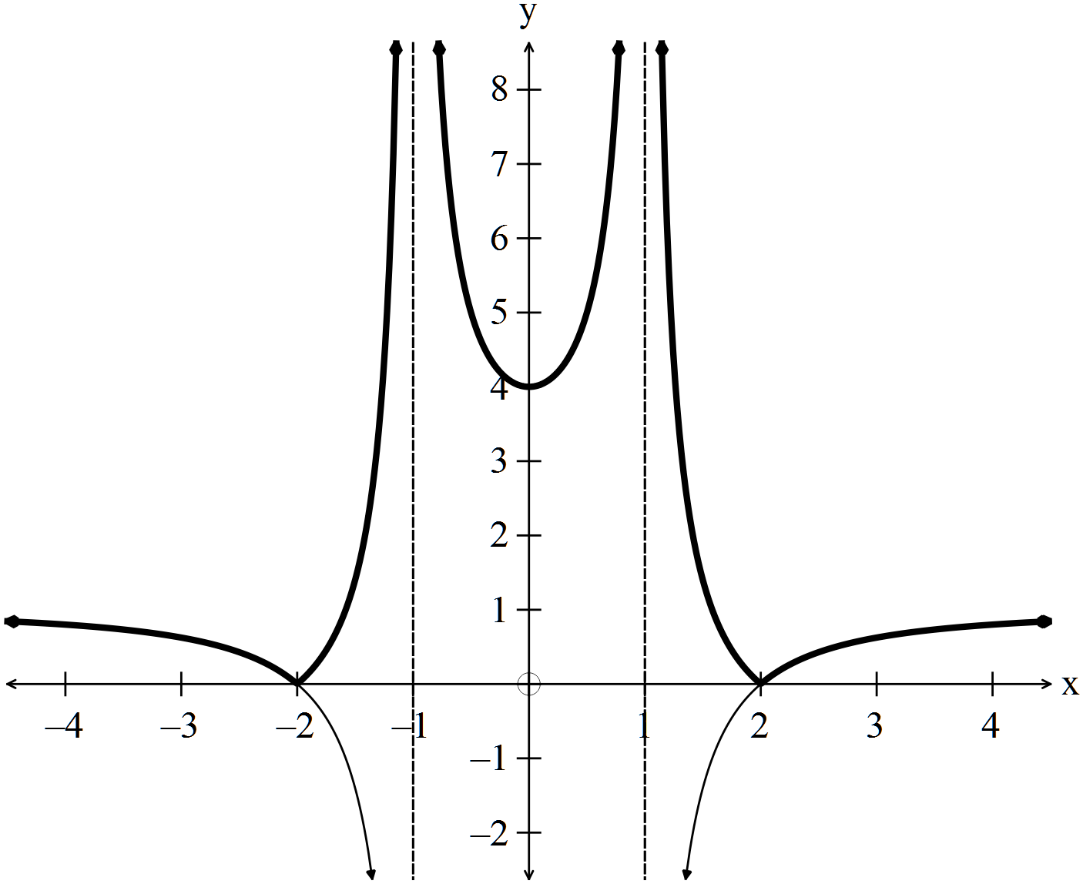
✓
✓
(2)
(ii) 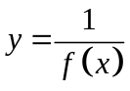
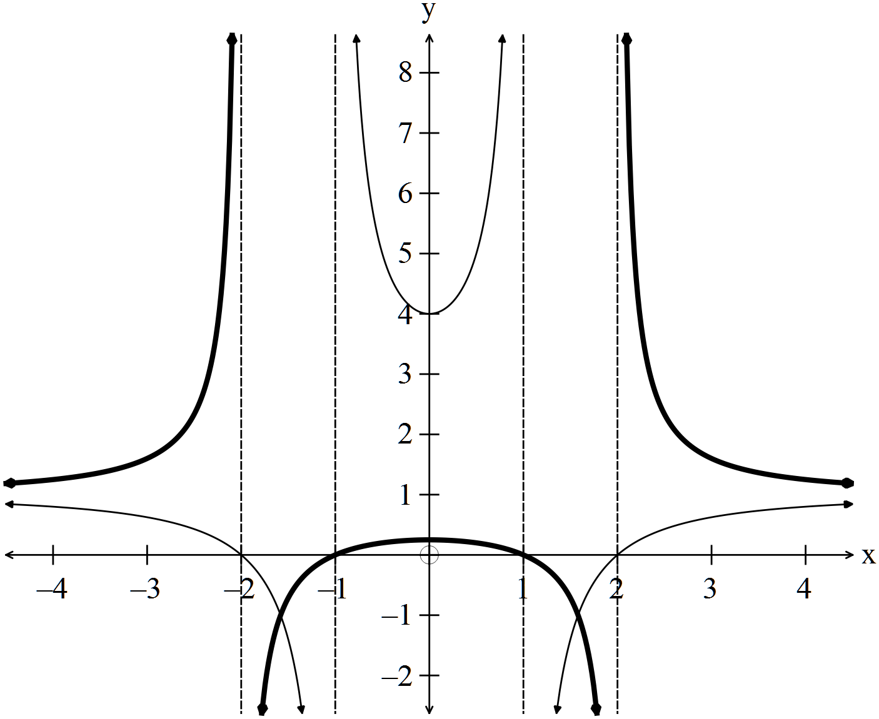
✓
✓
✓
(3)
2. (4 marks)
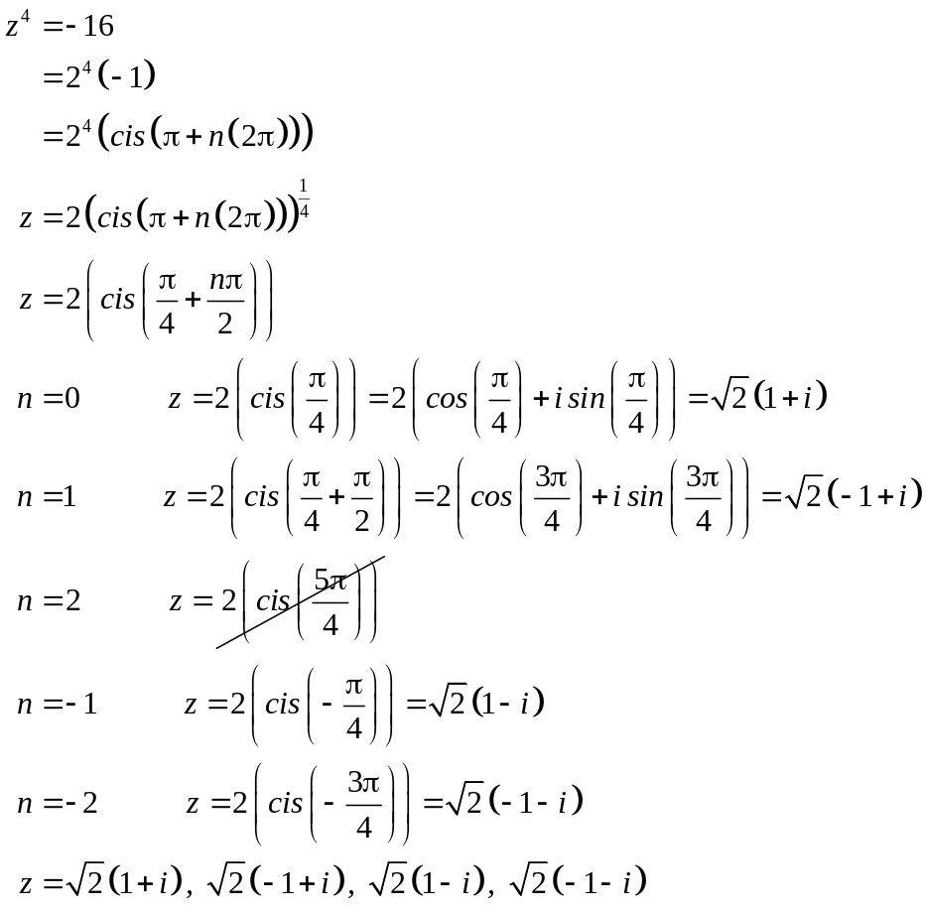
✓

✓✓✓ -1/error

(4)
3. (6 marks)
(a) 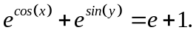
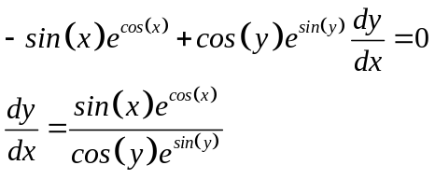
✓

✓✓✓ -1/error

(4)
(b) At (0,0) 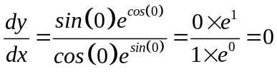 (2)
✓✓

4. (7 marks)
(a) Prove that “If 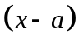is a factor of a polynomial,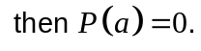”
Assume 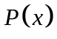 is a polynomial of degree.
Then 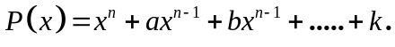
✓
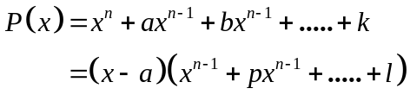
✓
since is a factor.
✓
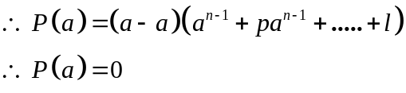
✓
Therefore, if is a factor, then 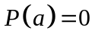
(4)
(b) 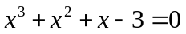
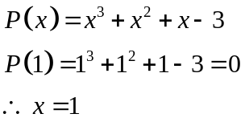
✓
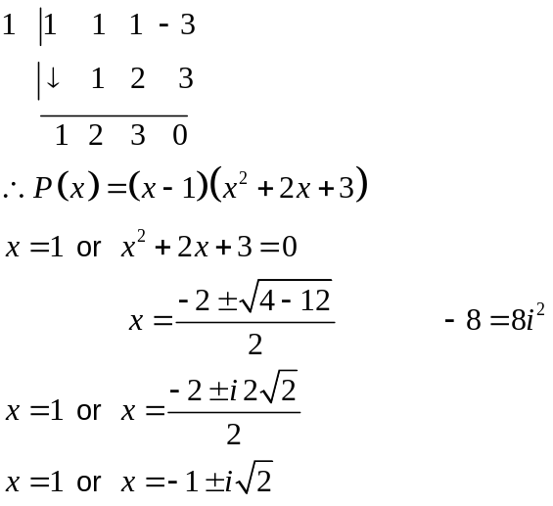
✓
(3)
✓
5. (10 marks)
(a) 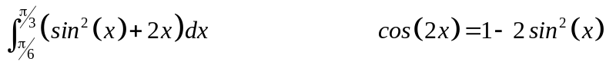
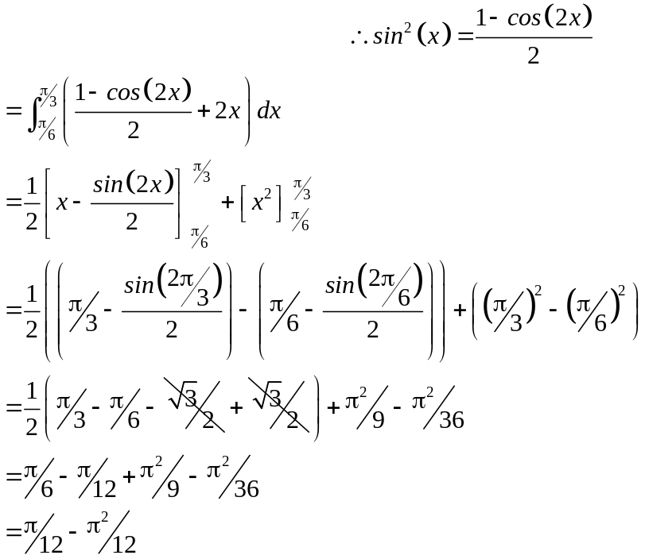
✓
✓
✓
(3)
(b)
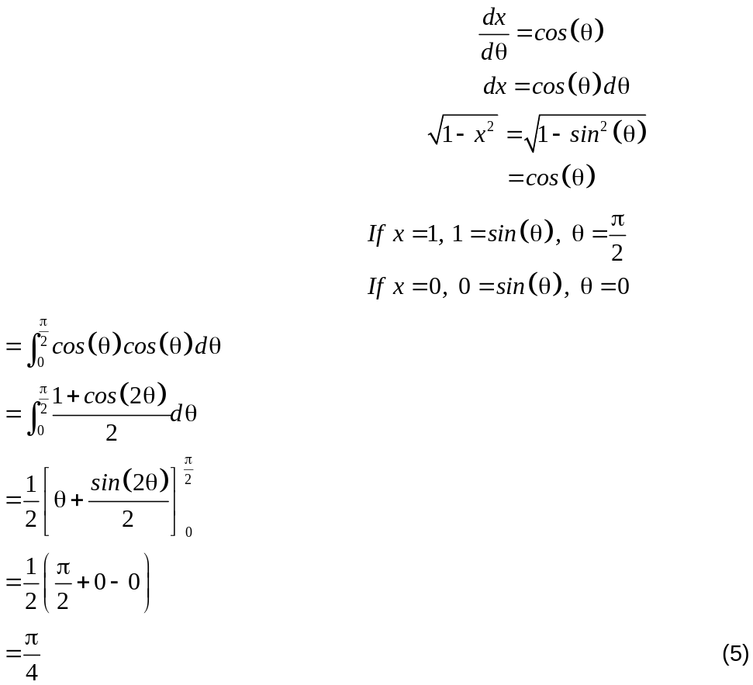
✓
✓
✓
✓
✓
(c) 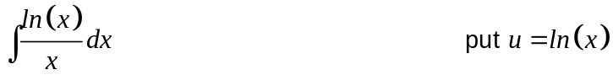
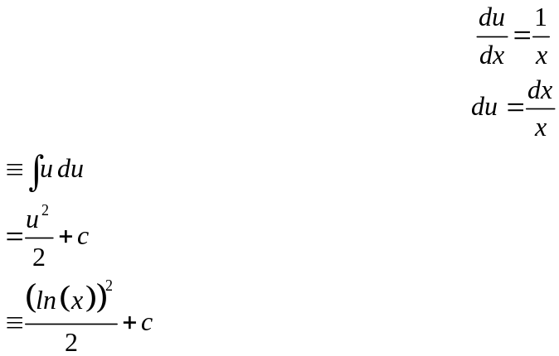
✓
✓
(2)
6. (12 marks)

(a) (i) At (-1, -1)
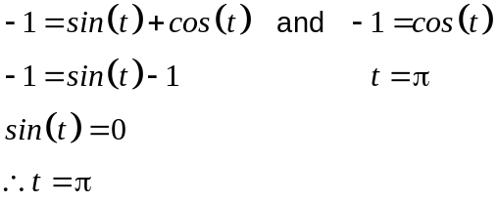
✓
✓
(2)
(ii) At 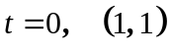 (1)
✓
(iii) 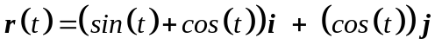
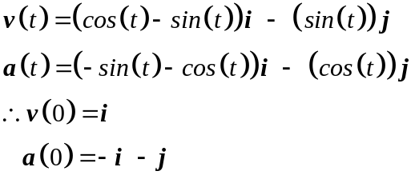
✓
✓
✓
(3)
(iv)
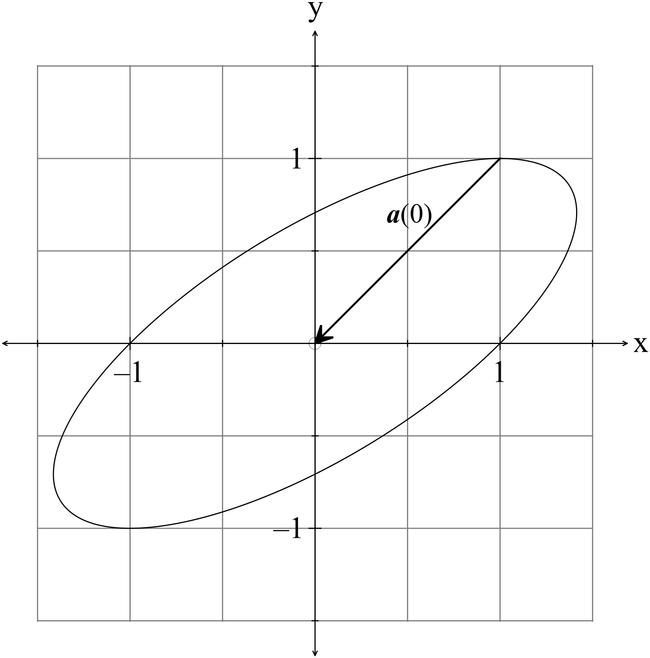
✓✓

(v)
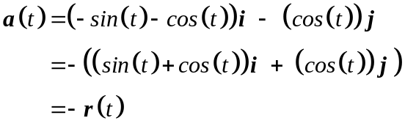
True for all values of . ✓ (1)

(b) 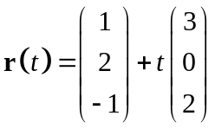 and the point 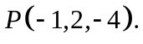
Does  belong to the line?

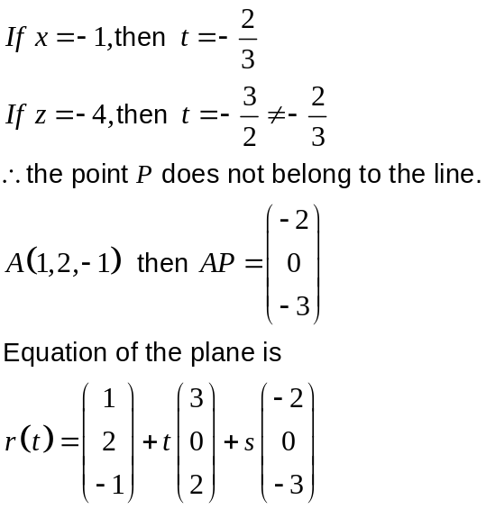
✓
✓
✓
(3)
7. (3 marks)

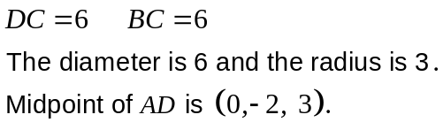
✓
✓
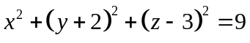
✓
(3)
8. (5 marks)
(a) 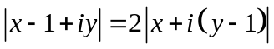
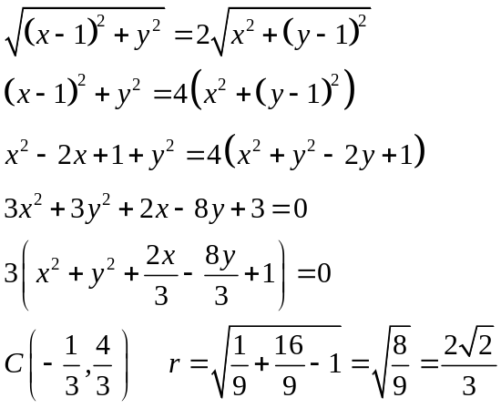
✓
✓
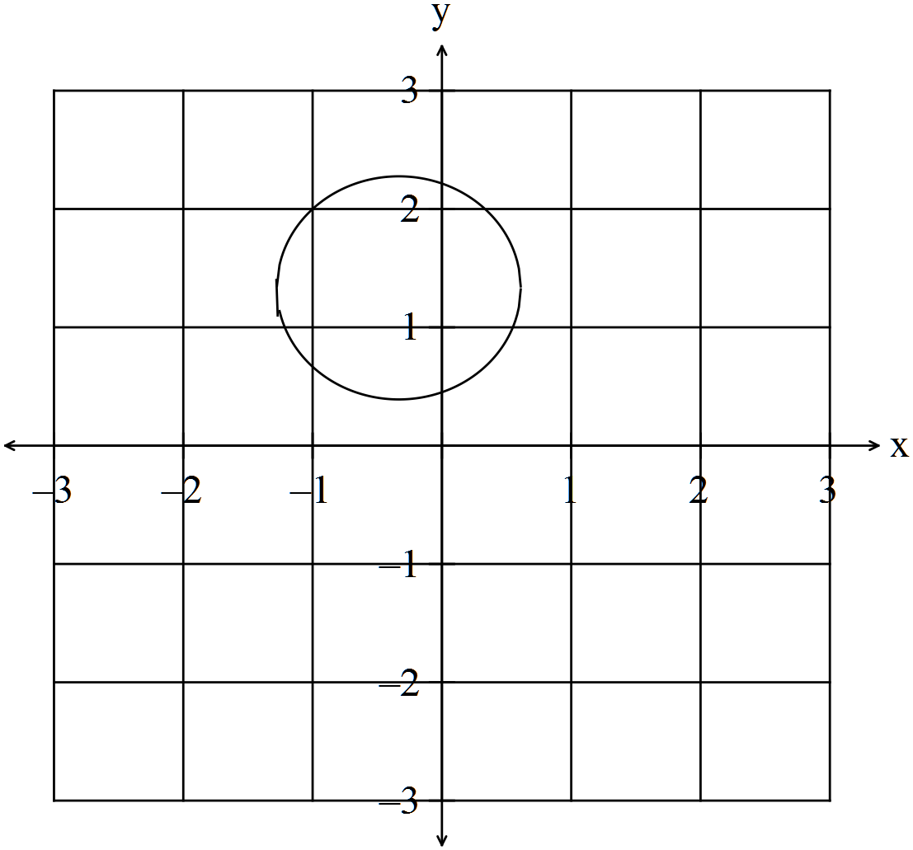
✓
(3)
(b) 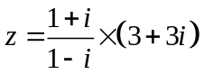 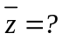
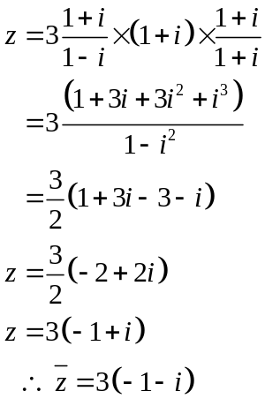
✓
✓
(2)

END OF SECTION ONE
Section Two
9. (4 marks)
(a) 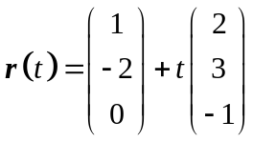 as 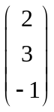 is perpendicular to the plane. ✓ (1)

(b) Determine if point 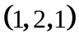 belongs to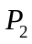.
Determine if point 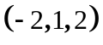 belongs to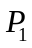. ✓
Find a point at random on by say letting 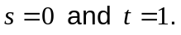 ✓
Substitute this point into .
If the point belongs to the plane, you have three non-linear points in two planes.
To check collinearity of the points find the equation of the line through two points and
see if the third point belongs to the line. ✓

ALTERNATIVELY find three points on one of the planes and test them in the
other plane. You need to test they are not collinear. (3)

10. (5 marks)
Boy: 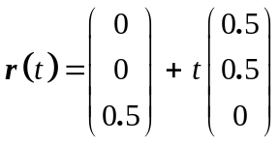 from 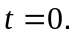
(a) Kookaburra
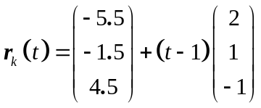
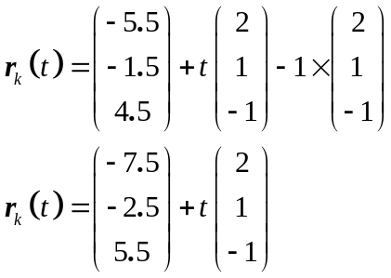 ✓
(1)

(b) Speed of kookaburra = 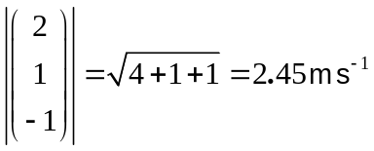 (1)
✓
(c) 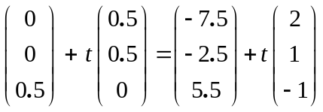 ✓
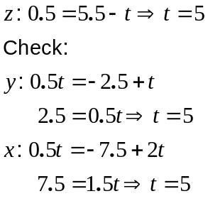
✓
The kookaburra takes 4 seconds to steal the sandwich. (He waits for one second). (3)
✓
11. (4 marks)
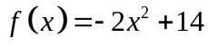 and 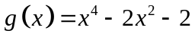
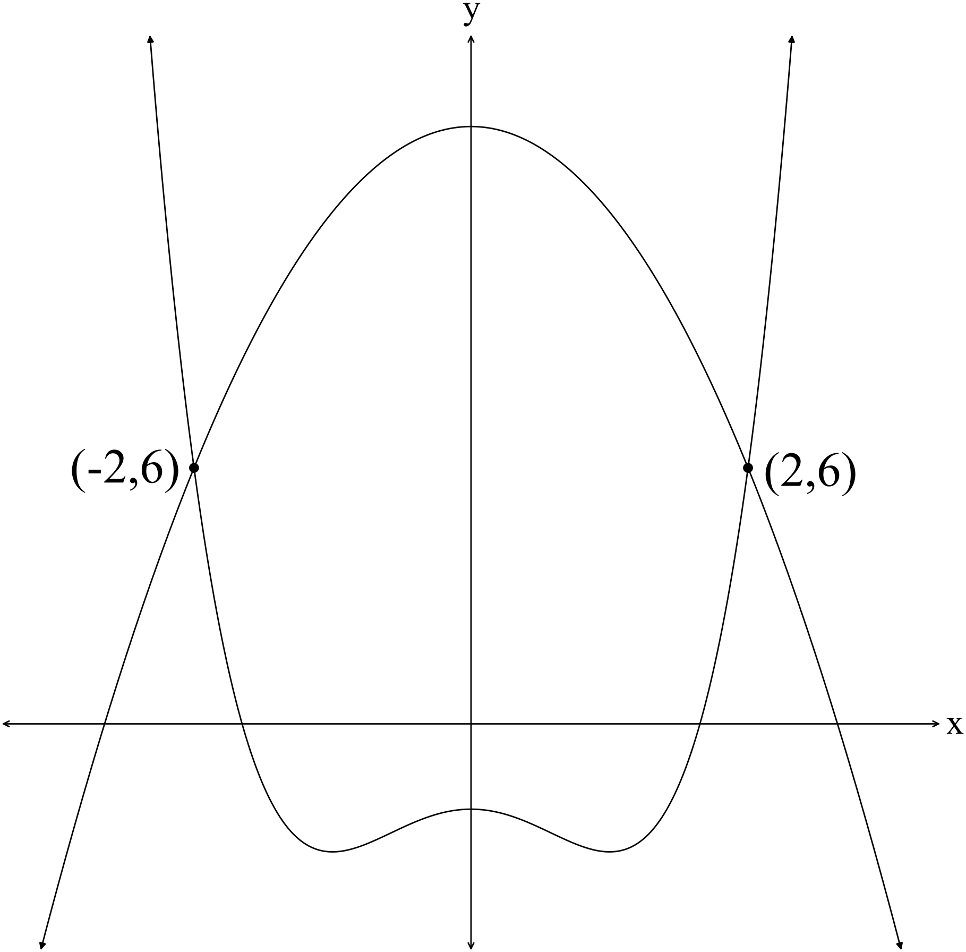
The x values of the intersection points are -2 and 2 ✓
Area = 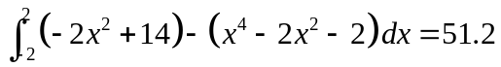
✓✓ ✓
12. (8 marks)
(a) Prove that 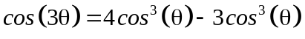
De Moivre's theorem states that
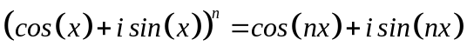
For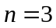
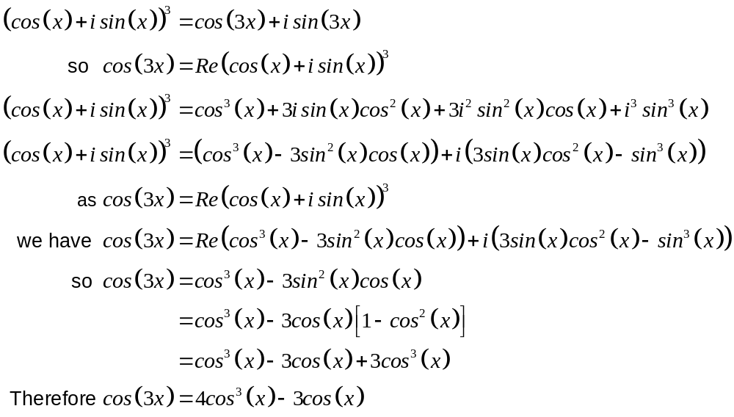 (6)
✓
✓
✓
✓
✓
✓
(b) 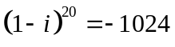 ✓✓ (2)

13. (17 marks)
(a) (i) 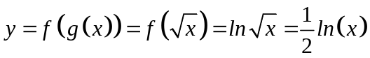 ✓
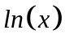 is defined for 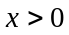 and this is the given domain so
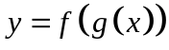 is defined. ✓ (2)
✓

(ii) 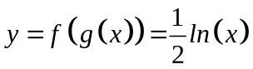 is monotonically increasing, so
has an inverse. (1)

(iii) 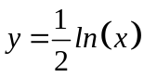
✓
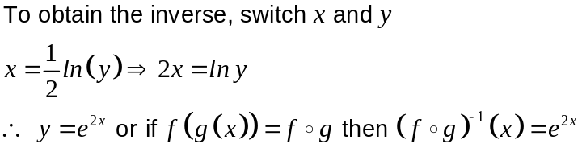
✓
✓
(3)

(b) (i) 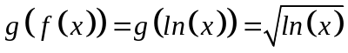
✓
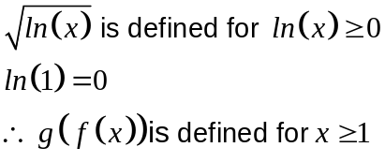
✓
✓
(3)
(ii) 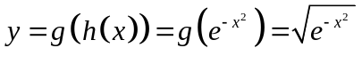
✓
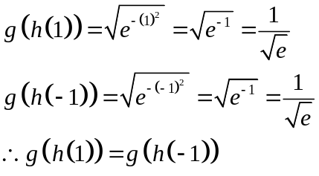
✓
The function 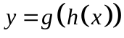is not a 1-1 function. (3)
✓

(c) (i) 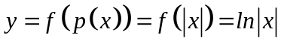 ✓

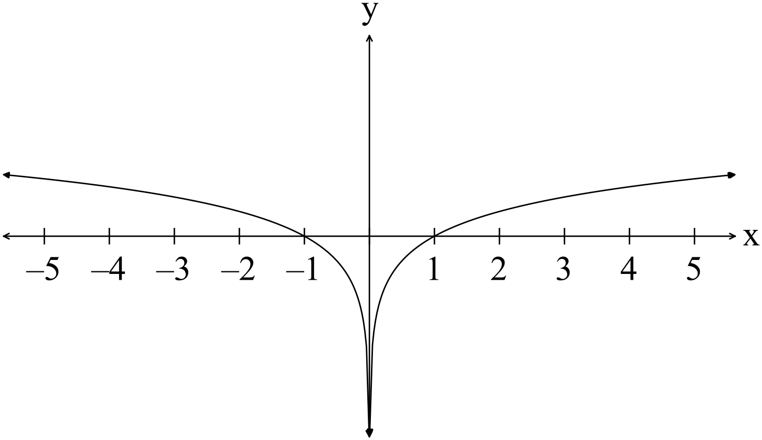✓

(2)

(ii) (2)
✓ ✓

14. (10 marks)
The function 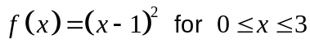 is rotated about theaxis.
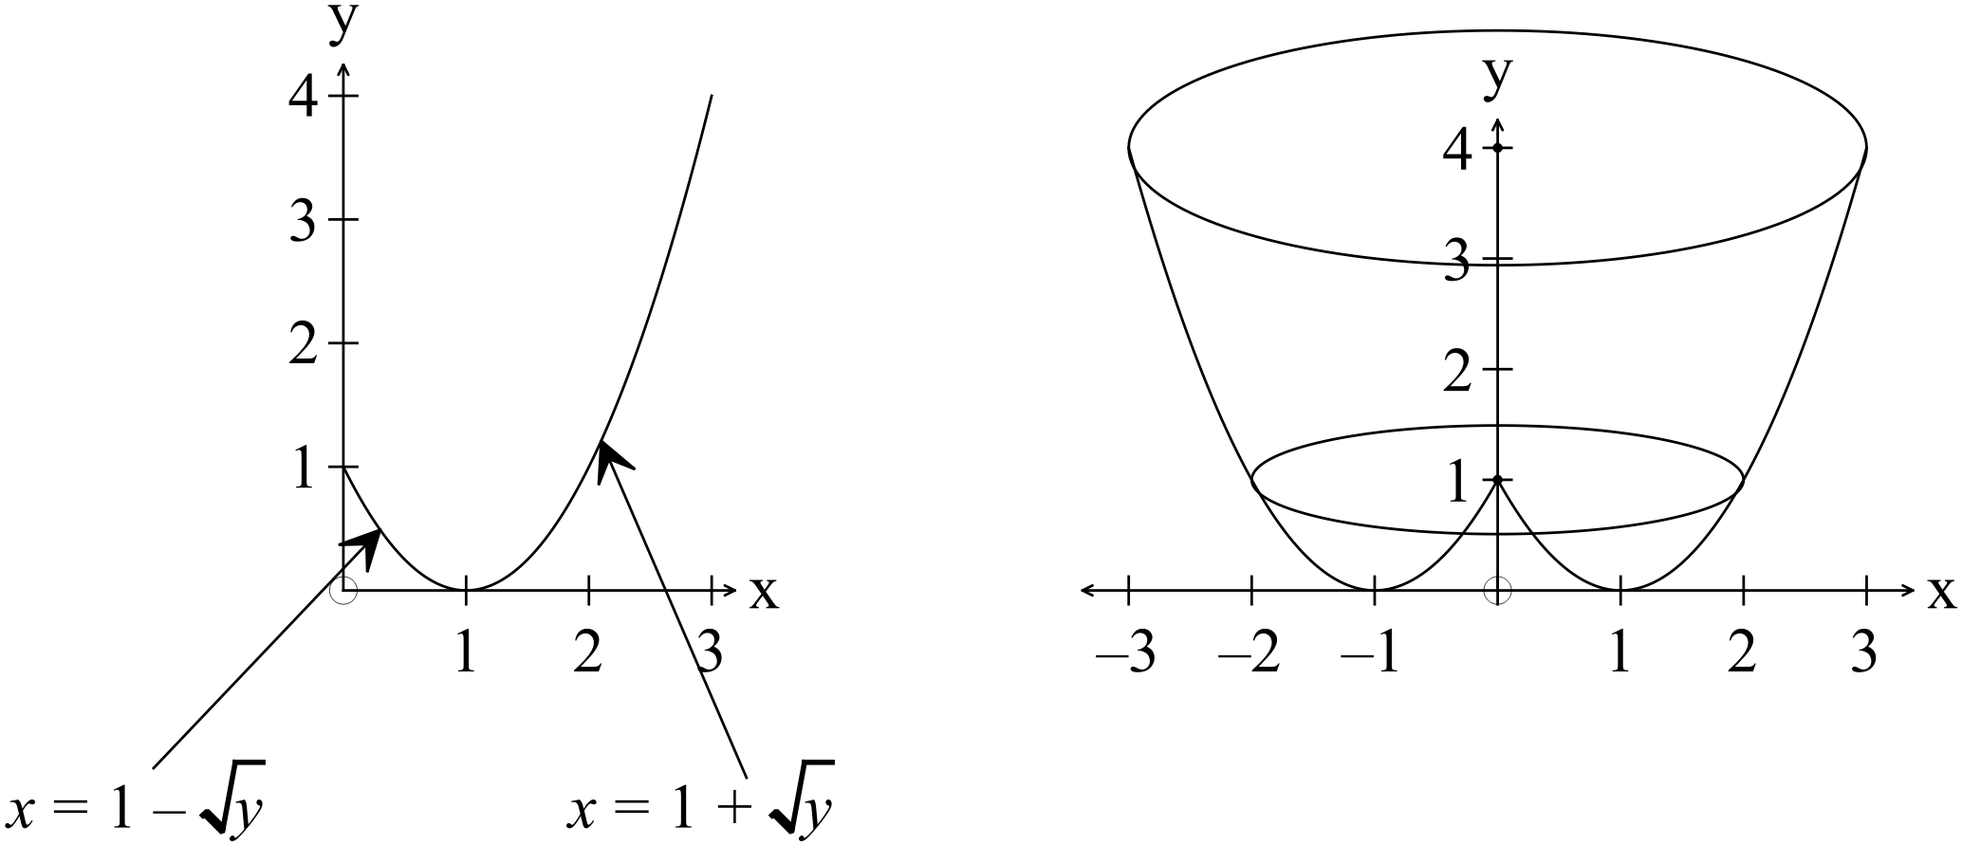
✓
✓

(a) 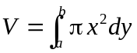
✓
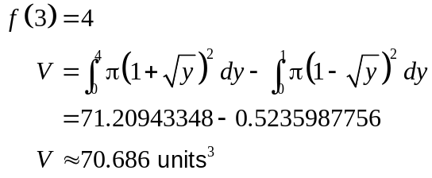
✓
✓
(5)
(b) 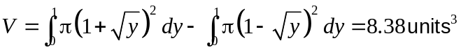 (1)
✓

(c) 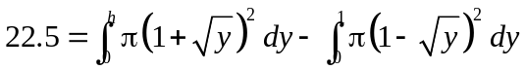
✓
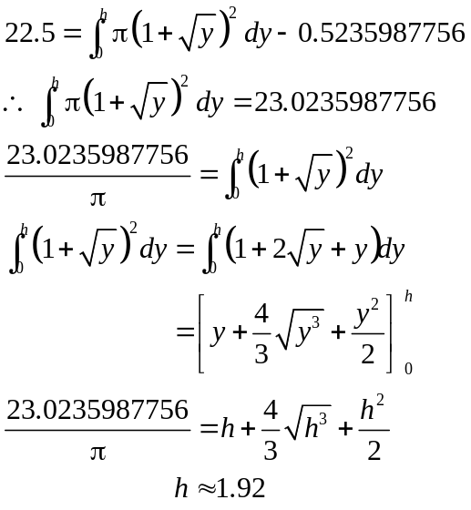
✓
✓
✓
(4)
15. (12 marks)
(a) 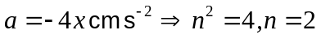
✓
Assume that
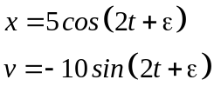
✓
✓
Therefore the maximum velocity is 10 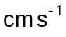
(which occurs when 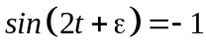). (3)

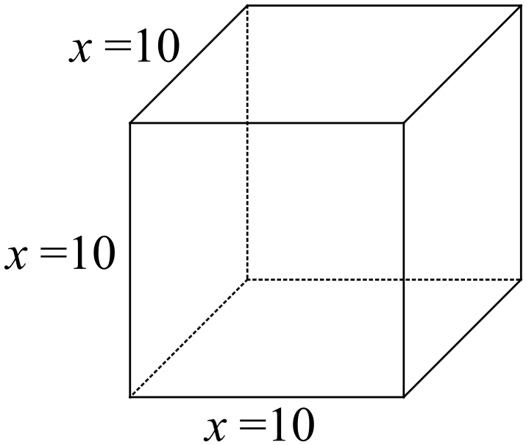 (b) 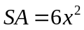
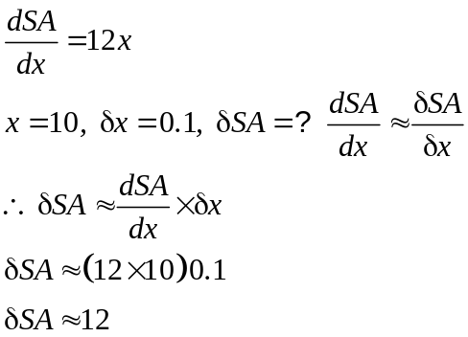
✓
✓
The increase in surface area, when the side increases from 10 to 10.1 cm,
✓
is 12 cm².

(3)
(c) 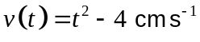
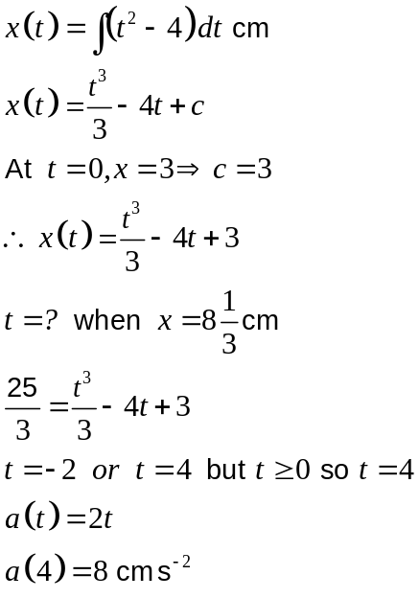
✓
✓
✓
(3)
(d) 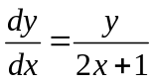
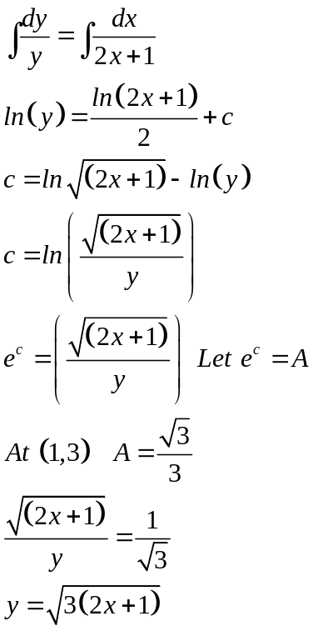 (3)
✓
✓
✓
16. (5 marks)
(a) 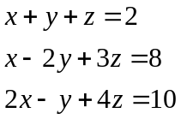
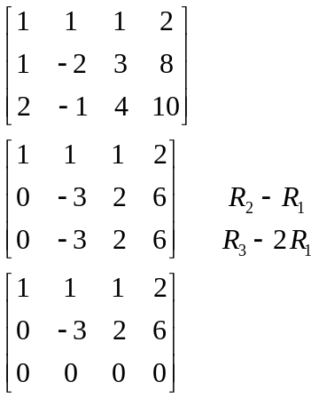
✓
✓

There are two dependant equations. None of the planes are parallel or identical
✓
planes, so the three planes intersect in a line. (2)

(b) 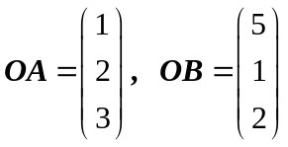
✓

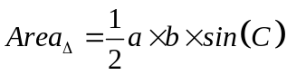
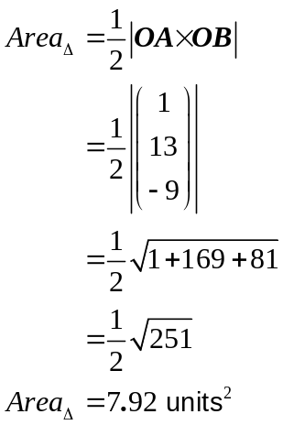
✓

✓

(3)
17. (12 marks)
(a) 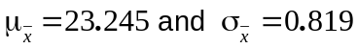 ✓ ✓ (2)
(b) 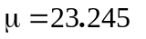 ✓
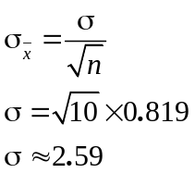
✓

(2)
(c) 99% confidence limits 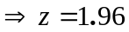
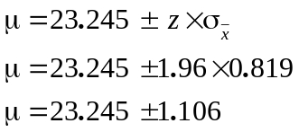
✓

Therefore we are 95% sure that 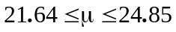 ✓ ✓ (3)
(d) 99% confidence limits 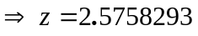
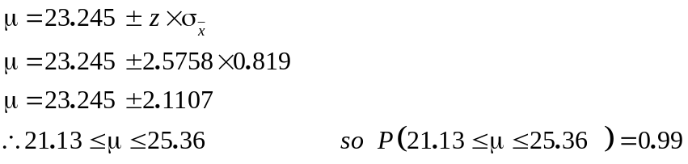
✓

✓

The 99% confidence limits are broader as you need to be MORE confident your results are correct. There is only room for 1% error so a wider range is given for the estimate of the mean. (3)
✓

18. (5 marks)
✓

(i) Each of the sampling distribtions will have a mean of 20.
The sampling distribution with have a much smaller standard deviation than the
original population as each of the points is an estimate of the mean of the
population.
The standard deviation of the sampling distributions is found by 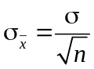.
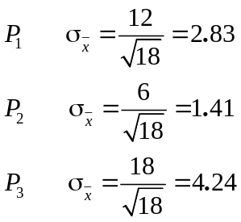

✓✓

It can be seen that the bigger the population standard deviation, the bigger the
✓

standard deviation of the sampling distributions.

(ii) Each of the sampling distributions are a tightly clustered normal distribution.
- (1)

19. (12 marks)
(a) 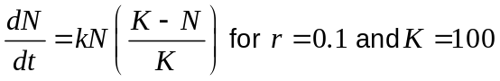

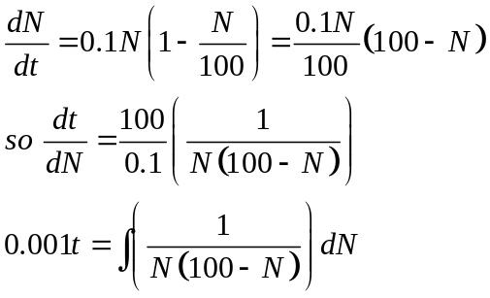
✓
Using partial fractions, 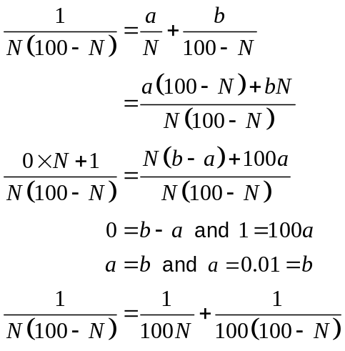
✓
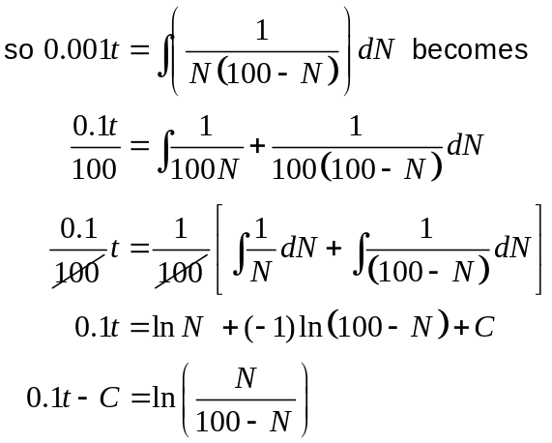
✓
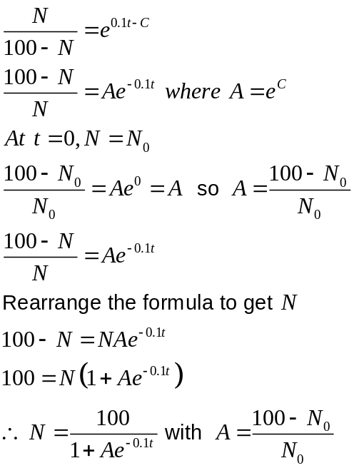
✓
(5)
✓

(b) (i) 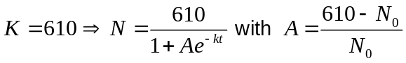
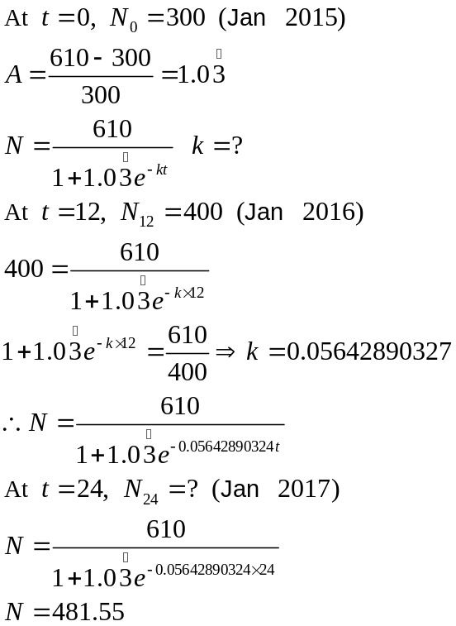
✓
✓
✓
✓
✓
The number of trout in the dam in January 2017 is expected to be close to 482.
(5)

(ii) 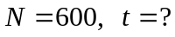
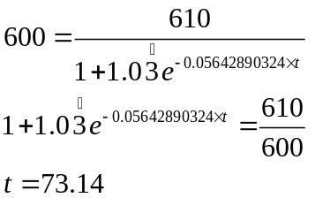
✓
✓
i.e. expect 600 trout in the dam in February 2021. (2)

20. (6 marks)
(a)
x | -2 | -1 | 0 | 1 | 2
y | 0 | 0 | 0 | 0 | 0
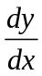 | -1 | 0 | 1 | 2 | 3

✓✓

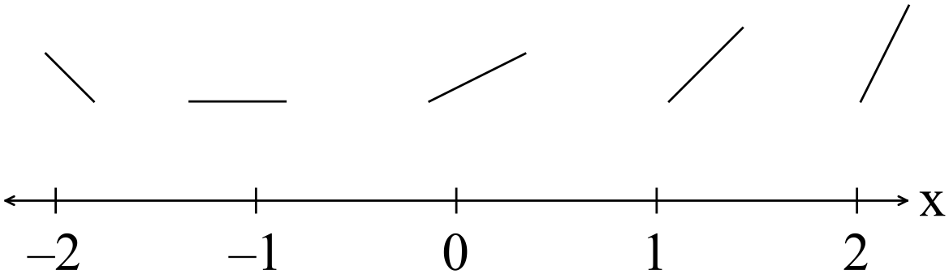
✓✓

(b)

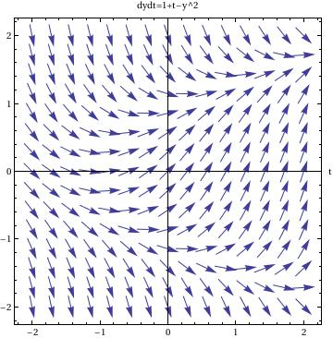
✓✓

(6)
END OF PAPER

